Федеральное агентство связи

Федеральное государственное бюджетное образовательное учреждение высшего образования

«Сибирский государственный университет телекоммуникаций и информатики»

Кафедра прикладной математики и кибернетики

Отчет по лабораторной работе

по дисциплине «Визуальное программирование»

Лабораторная работа № 6

«Работа с базами данных №1»

Выполнил: студент 2 курса группы ИП-811 Мироненко К. А

Проверил: доцент кафедры ПМиК Ситняковская Е. И.

**Оглавление**

1. Постановка задачи 3

2. Описание работы 4

3. Примеры работы программы 5

*Приложение* Листинг 12

# Постановка задачи

Создание небольшой реляционной базы данных и выгрузка ее в форму, так чтобы все связи изначальной базы данных были сохранены. Также необходимо создать инструменты управления выгруженными данными и создать поиск студента по заданной комбинации или по его точной фамилии.

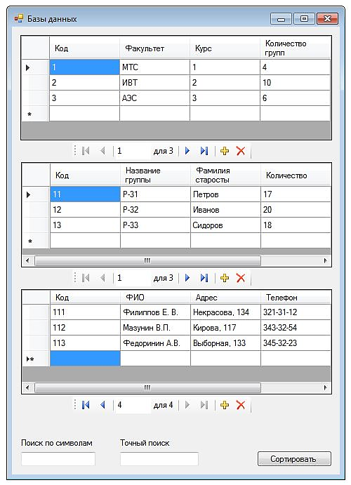

# Описание работы

Работа приложения соответствует описанию в методичке, за исключением именования и свойств некоторых элементов.

# Примеры работы программы

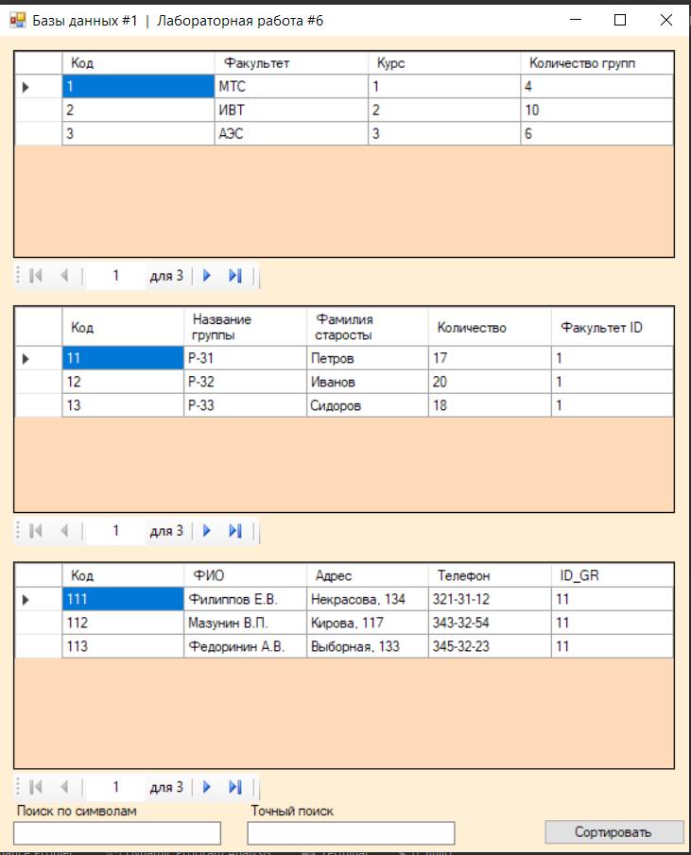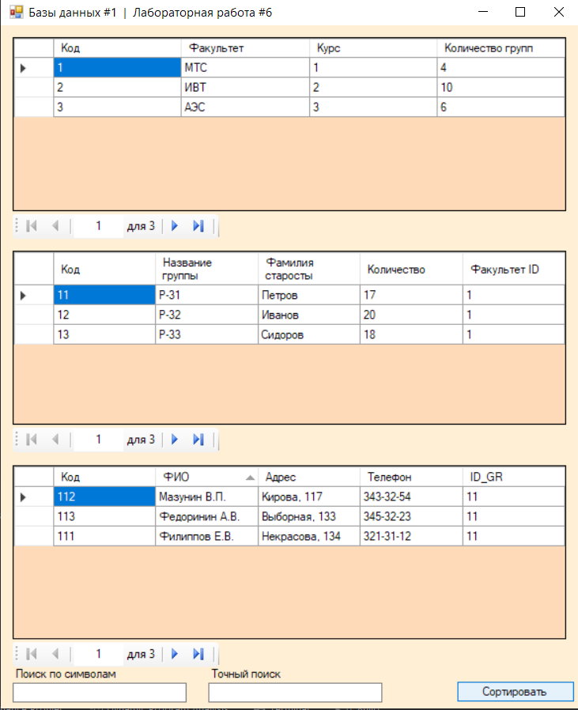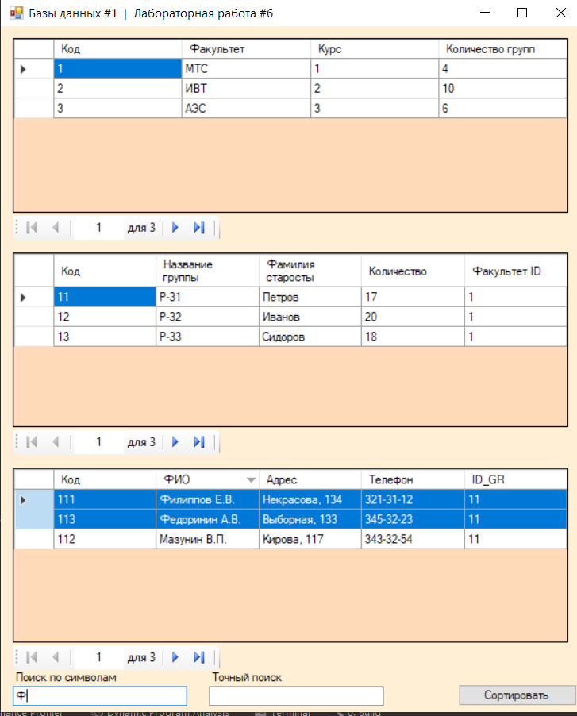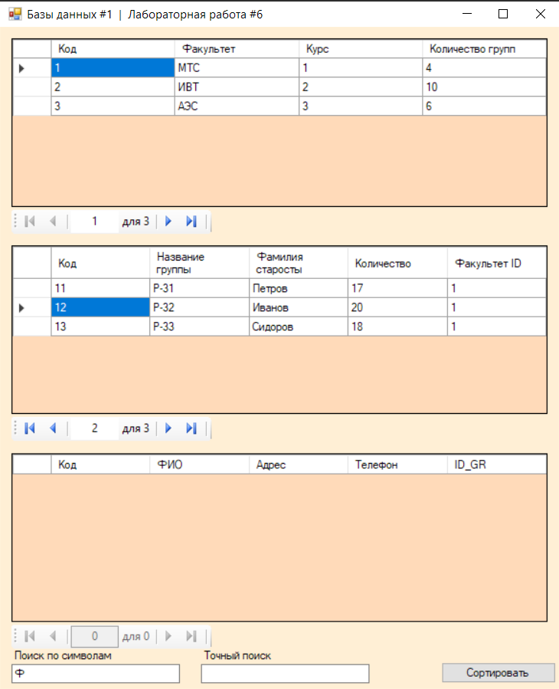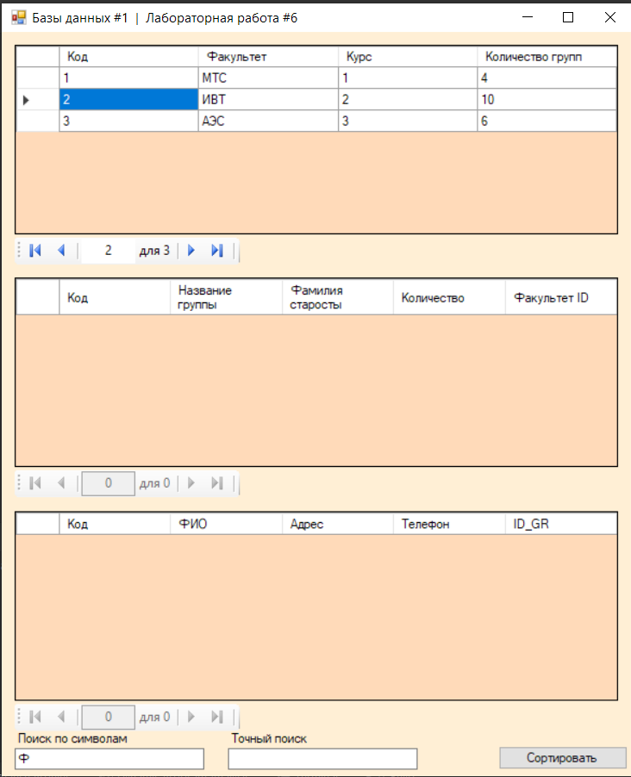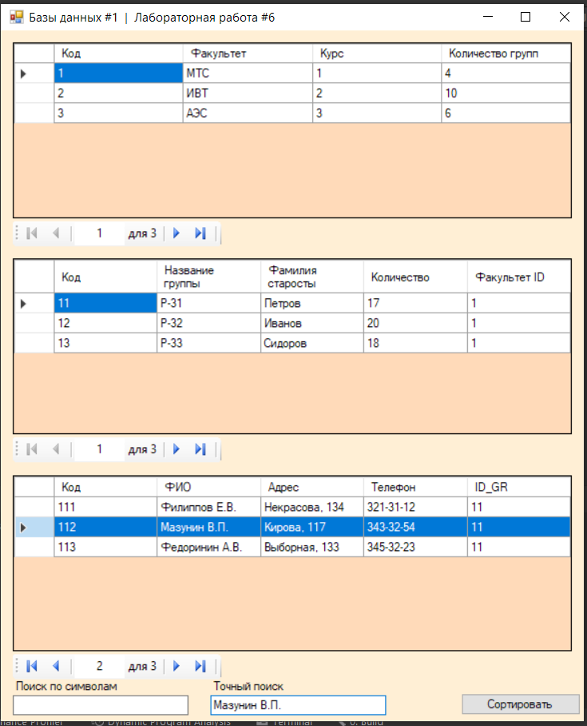

# *Приложение* Листинг

**Program.cs**

using System;

using System.Collections.Generic;

using System.Linq;

using System.Threading.Tasks;

using System.Windows.Forms;

namespace laboratoryWork_6

{

static class Program

{

/// <summary>

/// The main entry point for the application.

/// </summary>

[STAThread]

static void Main()

{

Application.EnableVisualStyles();

Application.SetCompatibleTextRenderingDefault(false);

Application.Run(new FormMain());

}

}

}

**FormMain.cs**

using System;

using System.Collections.Generic;

using System.ComponentModel;

using System.Data;

using System.Drawing;

using System.Linq;

using System.Text;

using System.Threading.Tasks;

using System.Windows.Forms;

namespace laboratoryWork_6

{

public partial class FormMain : Form

{

public FormMain()

{

InitializeComponent();

}

private void FormMain_Load(object sender, EventArgs e)

{

// TODO: данная строка кода позволяет загрузить данные в таблицу "dataBaseDataSet.Студенты". При необходимости она может быть перемещена или удалена.

this.студентыTableAdapter.Fill(this.dataBaseDataSet.Студенты);

// TODO: данная строка кода позволяет загрузить данные в таблицу "dataBaseDataSet.Группа". При необходимости она может быть перемещена или удалена.

this.группаTableAdapter.Fill(this.dataBaseDataSet.Группа);

// TODO: данная строка кода позволяет загрузить данные в таблицу "dataBaseDataSet.Факультет". При необходимости она может быть перемещена или удалена.

this.факультетTableAdapter.Fill(this.dataBaseDataSet.Факультет);

}

private void button1_Click(object sender, EventArgs e)

{

if (students_dataGridView.SortOrder == SortOrder.Ascending)

students_dataGridView.Sort(students_dataGridView.Columns[1], ListSortDirection.Descending);

else

students_dataGridView.Sort(students_dataGridView.Columns[1], ListSortDirection.Ascending);

}

private void textBox1_TextChanged(object sender, EventArgs e)

{

for (int i = 0; i < students_dataGridView.RowCount - 1; i++)

{

string str = students_dataGridView.Rows[i].Cells[1].Value.ToString();

if (str.Contains(textBox1.Text) == true)

students_dataGridView.Rows[i].Selected = true;

else

students_dataGridView.Rows[i].Selected = false;

if (textBox1.Text == "")

students_dataGridView.Rows[i].Selected = false;

}

}

private void textBox2_TextChanged(object sender, EventArgs e)

{

for (int i = 0; i < students_dataGridView.RowCount - 1; i++)

{

string str = students_dataGridView.Rows[i].Cells[1].Value.ToString();

if (str == textBox2.Text)

students_dataGridView.Rows[i].Selected = true;

else

students_dataGridView.Rows[i].Selected = false;

}

}

}

}

**FormMain.Designer.cs**

namespace laboratoryWork_6

{

partial class FormMain

{

/// <summary>

/// Required designer variable.

/// </summary>

private System.ComponentModel.IContainer components = null;

/// <summary>

/// Clean up any resources being used.

/// </summary>

/// <param name="disposing">true if managed resources should be disposed; otherwise, false.</param>

protected override void Dispose(bool disposing)

{

if (disposing && (components != null))

{

components.Dispose();

}

base.Dispose(disposing);

}

#region Windows Form Designer generated code

/// <summary>

/// Required method for Designer support - do not modify

/// the contents of this method with the code editor.

/// </summary>

private void InitializeComponent()

{

this.components = new System.ComponentModel.Container();

System.ComponentModel.ComponentResourceManager resources = new System.ComponentModel.ComponentResourceManager(typeof(FormMain));

this.faculty_dataGridView = new System.Windows.Forms.DataGridView();

this.кодDataGridViewTextBoxColumn = new System.Windows.Forms.DataGridViewTextBoxColumn();

this.факультетDataGridViewTextBoxColumn = new System.Windows.Forms.DataGridViewTextBoxColumn();

this.курсDataGridViewTextBoxColumn = new System.Windows.Forms.DataGridViewTextBoxColumn();

this.количествоГруппDataGridViewTextBoxColumn = new System.Windows.Forms.DataGridViewTextBoxColumn();

this.факультетBindingSource = new System.Windows.Forms.BindingSource(this.components);

this.dataBaseDataSet = new laboratoryWork_6.DataBaseDataSet();

this.groups_dataGridView = new System.Windows.Forms.DataGridView();

this.кодDataGridViewTextBoxColumn1 = new System.Windows.Forms.DataGridViewTextBoxColumn();

this.названиеГруппыDataGridViewTextBoxColumn = new System.Windows.Forms.DataGridViewTextBoxColumn();

this.фамилияСтаростыDataGridViewTextBoxColumn = new System.Windows.Forms.DataGridViewTextBoxColumn();

this.количествоDataGridViewTextBoxColumn = new System.Windows.Forms.DataGridViewTextBoxColumn();

this.факультетIDDataGridViewTextBoxColumn = new System.Windows.Forms.DataGridViewTextBoxColumn();

this.группаBindingSource = new System.Windows.Forms.BindingSource(this.components);

this.students_dataGridView = new System.Windows.Forms.DataGridView();

this.кодDataGridViewTextBoxColumn2 = new System.Windows.Forms.DataGridViewTextBoxColumn();

this.фИОDataGridViewTextBoxColumn = new System.Windows.Forms.DataGridViewTextBoxColumn();

this.адресDataGridViewTextBoxColumn = new System.Windows.Forms.DataGridViewTextBoxColumn();

this.телефонDataGridViewTextBoxColumn = new System.Windows.Forms.DataGridViewTextBoxColumn();

this.iDGRDataGridViewTextBoxColumn = new System.Windows.Forms.DataGridViewTextBoxColumn();

this.студентыBindingSource = new System.Windows.Forms.BindingSource(this.components);

this.faculty_bindingNavigator = new System.Windows.Forms.BindingNavigator(this.components);

this.bindingNavigatorCountItem = new System.Windows.Forms.ToolStripLabel();

this.bindingNavigatorMoveFirstItem = new System.Windows.Forms.ToolStripButton();

this.bindingNavigatorMovePreviousItem = new System.Windows.Forms.ToolStripButton();

this.bindingNavigatorSeparator = new System.Windows.Forms.ToolStripSeparator();

this.faculty_bindingNavigatorPositionItem = new System.Windows.Forms.ToolStripTextBox();

this.bindingNavigatorSeparator1 = new System.Windows.Forms.ToolStripSeparator();

this.bindingNavigatorMoveNextItem = new System.Windows.Forms.ToolStripButton();

this.bindingNavigatorMoveLastItem = new System.Windows.Forms.ToolStripButton();

this.bindingNavigatorSeparator2 = new System.Windows.Forms.ToolStripSeparator();

this.groups_bindingNavigator = new System.Windows.Forms.BindingNavigator(this.components);

this.toolStripLabel1 = new System.Windows.Forms.ToolStripLabel();

this.toolStripButton1 = new System.Windows.Forms.ToolStripButton();

this.toolStripButton2 = new System.Windows.Forms.ToolStripButton();

this.toolStripSeparator1 = new System.Windows.Forms.ToolStripSeparator();

this.toolStripTextBox1 = new System.Windows.Forms.ToolStripTextBox();

this.toolStripSeparator2 = new System.Windows.Forms.ToolStripSeparator();

this.toolStripButton3 = new System.Windows.Forms.ToolStripButton();

this.toolStripButton4 = new System.Windows.Forms.ToolStripButton();

this.toolStripSeparator3 = new System.Windows.Forms.ToolStripSeparator();

this.students_bindingNavigator = new System.Windows.Forms.BindingNavigator(this.components);

this.toolStripLabel2 = new System.Windows.Forms.ToolStripLabel();

this.toolStripButton5 = new System.Windows.Forms.ToolStripButton();

this.toolStripButton6 = new System.Windows.Forms.ToolStripButton();

this.toolStripSeparator4 = new System.Windows.Forms.ToolStripSeparator();

this.toolStripTextBox2 = new System.Windows.Forms.ToolStripTextBox();

this.toolStripSeparator5 = new System.Windows.Forms.ToolStripSeparator();

this.toolStripButton7 = new System.Windows.Forms.ToolStripButton();

this.toolStripButton8 = new System.Windows.Forms.ToolStripButton();

this.toolStripSeparator6 = new System.Windows.Forms.ToolStripSeparator();

this.факультетTableAdapter = new laboratoryWork_6.DataBaseDataSetTableAdapters.ФакультетTableAdapter();

this.группаTableAdapter = new laboratoryWork_6.DataBaseDataSetTableAdapters.ГруппаTableAdapter();

this.студентыTableAdapter = new laboratoryWork_6.DataBaseDataSetTableAdapters.СтудентыTableAdapter();

this.textBox1 = new System.Windows.Forms.TextBox();

this.textBox2 = new System.Windows.Forms.TextBox();

this.button1 = new System.Windows.Forms.Button();

this.label1 = new System.Windows.Forms.Label();

this.label2 = new System.Windows.Forms.Label();

this.факультетГруппаBindingSource = new System.Windows.Forms.BindingSource(this.components);

this.группаСтудентыBindingSource = new System.Windows.Forms.BindingSource(this.components);

((System.ComponentModel.ISupportInitialize)(this.faculty_dataGridView)).BeginInit();

((System.ComponentModel.ISupportInitialize)(this.факультетBindingSource)).BeginInit();

((System.ComponentModel.ISupportInitialize)(this.dataBaseDataSet)).BeginInit();

((System.ComponentModel.ISupportInitialize)(this.groups_dataGridView)).BeginInit();

((System.ComponentModel.ISupportInitialize)(this.группаBindingSource)).BeginInit();

((System.ComponentModel.ISupportInitialize)(this.students_dataGridView)).BeginInit();

((System.ComponentModel.ISupportInitialize)(this.студентыBindingSource)).BeginInit();

((System.ComponentModel.ISupportInitialize)(this.faculty_bindingNavigator)).BeginInit();

this.faculty_bindingNavigator.SuspendLayout();

((System.ComponentModel.ISupportInitialize)(this.groups_bindingNavigator)).BeginInit();

this.groups_bindingNavigator.SuspendLayout();

((System.ComponentModel.ISupportInitialize)(this.students_bindingNavigator)).BeginInit();

this.students_bindingNavigator.SuspendLayout();

((System.ComponentModel.ISupportInitialize)(this.факультетГруппаBindingSource)).BeginInit();

((System.ComponentModel.ISupportInitialize)(this.группаСтудентыBindingSource)).BeginInit();

this.SuspendLayout();

//

// faculty_dataGridView

//

this.faculty_dataGridView.AllowUserToAddRows = false;

this.faculty_dataGridView.AllowUserToDeleteRows = false;

this.faculty_dataGridView.AllowUserToResizeColumns = false;

this.faculty_dataGridView.AllowUserToResizeRows = false;

this.faculty_dataGridView.Anchor = ((System.Windows.Forms.AnchorStyles)(((System.Windows.Forms.AnchorStyles.Top | System.Windows.Forms.AnchorStyles.Left)

| System.Windows.Forms.AnchorStyles.Right)));

this.faculty_dataGridView.AutoGenerateColumns = false;

this.faculty_dataGridView.AutoSizeColumnsMode = System.Windows.Forms.DataGridViewAutoSizeColumnsMode.Fill;

this.faculty_dataGridView.AutoSizeRowsMode = System.Windows.Forms.DataGridViewAutoSizeRowsMode.DisplayedCells;

this.faculty_dataGridView.BackgroundColor = System.Drawing.Color.PeachPuff;

this.faculty_dataGridView.ColumnHeadersBorderStyle = System.Windows.Forms.DataGridViewHeaderBorderStyle.Single;

this.faculty_dataGridView.ColumnHeadersHeightSizeMode = System.Windows.Forms.DataGridViewColumnHeadersHeightSizeMode.AutoSize;

this.faculty_dataGridView.Columns.AddRange(new System.Windows.Forms.DataGridViewColumn[] {

this.кодDataGridViewTextBoxColumn,

this.факультетDataGridViewTextBoxColumn,

this.курсDataGridViewTextBoxColumn,

this.количествоГруппDataGridViewTextBoxColumn});

this.faculty_dataGridView.DataSource = this.факультетBindingSource;

this.faculty_dataGridView.EditMode = System.Windows.Forms.DataGridViewEditMode.EditProgrammatically;

this.faculty_dataGridView.Location = new System.Drawing.Point(12, 12);

this.faculty_dataGridView.Name = "faculty_dataGridView";

this.faculty_dataGridView.ReadOnly = true;

this.faculty_dataGridView.Size = new System.Drawing.Size(560, 176);

this.faculty_dataGridView.TabIndex = 0;

//

// кодDataGridViewTextBoxColumn

//

this.кодDataGridViewTextBoxColumn.DataPropertyName = "Код";

this.кодDataGridViewTextBoxColumn.HeaderText = "Код";

this.кодDataGridViewTextBoxColumn.Name = "кодDataGridViewTextBoxColumn";

this.кодDataGridViewTextBoxColumn.ReadOnly = true;

//

// факультетDataGridViewTextBoxColumn

//

this.факультетDataGridViewTextBoxColumn.DataPropertyName = "Факультет";

this.факультетDataGridViewTextBoxColumn.HeaderText = "Факультет";

this.факультетDataGridViewTextBoxColumn.Name = "факультетDataGridViewTextBoxColumn";

this.факультетDataGridViewTextBoxColumn.ReadOnly = true;

//

// курсDataGridViewTextBoxColumn

//

this.курсDataGridViewTextBoxColumn.DataPropertyName = "Курс";

this.курсDataGridViewTextBoxColumn.HeaderText = "Курс";

this.курсDataGridViewTextBoxColumn.Name = "курсDataGridViewTextBoxColumn";

this.курсDataGridViewTextBoxColumn.ReadOnly = true;

//

// количествоГруппDataGridViewTextBoxColumn

//

this.количествоГруппDataGridViewTextBoxColumn.DataPropertyName = "Количество групп";

this.количествоГруппDataGridViewTextBoxColumn.HeaderText = "Количество групп";

this.количествоГруппDataGridViewTextBoxColumn.Name = "количествоГруппDataGridViewTextBoxColumn";

this.количествоГруппDataGridViewTextBoxColumn.ReadOnly = true;

//

// факультетBindingSource

//

this.факультетBindingSource.DataMember = "Факультет";

this.факультетBindingSource.DataSource = this.dataBaseDataSet;

//

// dataBaseDataSet

//

this.dataBaseDataSet.DataSetName = "DataBaseDataSet";

this.dataBaseDataSet.SchemaSerializationMode = System.Data.SchemaSerializationMode.IncludeSchema;

//

// groups_dataGridView

//

this.groups_dataGridView.AllowUserToAddRows = false;

this.groups_dataGridView.AllowUserToDeleteRows = false;

this.groups_dataGridView.AllowUserToResizeColumns = false;

this.groups_dataGridView.AllowUserToResizeRows = false;

this.groups_dataGridView.Anchor = ((System.Windows.Forms.AnchorStyles)(((System.Windows.Forms.AnchorStyles.Top | System.Windows.Forms.AnchorStyles.Left)

| System.Windows.Forms.AnchorStyles.Right)));

this.groups_dataGridView.AutoGenerateColumns = false;

this.groups_dataGridView.AutoSizeColumnsMode = System.Windows.Forms.DataGridViewAutoSizeColumnsMode.Fill;

this.groups_dataGridView.AutoSizeRowsMode = System.Windows.Forms.DataGridViewAutoSizeRowsMode.DisplayedCells;

this.groups_dataGridView.BackgroundColor = System.Drawing.Color.PeachPuff;

this.groups_dataGridView.ColumnHeadersHeightSizeMode = System.Windows.Forms.DataGridViewColumnHeadersHeightSizeMode.AutoSize;

this.groups_dataGridView.Columns.AddRange(new System.Windows.Forms.DataGridViewColumn[] {

this.кодDataGridViewTextBoxColumn1,

this.названиеГруппыDataGridViewTextBoxColumn,

this.фамилияСтаростыDataGridViewTextBoxColumn,

this.количествоDataGridViewTextBoxColumn,

this.факультетIDDataGridViewTextBoxColumn});

this.groups_dataGridView.DataSource = this.факультетГруппаBindingSource;

this.groups_dataGridView.Location = new System.Drawing.Point(12, 228);

this.groups_dataGridView.Name = "groups_dataGridView";

this.groups_dataGridView.ReadOnly = true;

this.groups_dataGridView.ShowEditingIcon = false;

this.groups_dataGridView.Size = new System.Drawing.Size(560, 176);

this.groups_dataGridView.TabIndex = 1;

//

// кодDataGridViewTextBoxColumn1

//

this.кодDataGridViewTextBoxColumn1.DataPropertyName = "Код";

this.кодDataGridViewTextBoxColumn1.HeaderText = "Код";

this.кодDataGridViewTextBoxColumn1.Name = "кодDataGridViewTextBoxColumn1";

this.кодDataGridViewTextBoxColumn1.ReadOnly = true;

//

// названиеГруппыDataGridViewTextBoxColumn

//

this.названиеГруппыDataGridViewTextBoxColumn.DataPropertyName = "Название группы";

this.названиеГруппыDataGridViewTextBoxColumn.HeaderText = "Название группы";

this.названиеГруппыDataGridViewTextBoxColumn.Name = "названиеГруппыDataGridViewTextBoxColumn";

this.названиеГруппыDataGridViewTextBoxColumn.ReadOnly = true;

//

// фамилияСтаростыDataGridViewTextBoxColumn

//

this.фамилияСтаростыDataGridViewTextBoxColumn.DataPropertyName = "Фамилия старосты";

this.фамилияСтаростыDataGridViewTextBoxColumn.HeaderText = "Фамилия старосты";

this.фамилияСтаростыDataGridViewTextBoxColumn.Name = "фамилияСтаростыDataGridViewTextBoxColumn";

this.фамилияСтаростыDataGridViewTextBoxColumn.ReadOnly = true;

//

// количествоDataGridViewTextBoxColumn

//

this.количествоDataGridViewTextBoxColumn.DataPropertyName = "Количество";

this.количествоDataGridViewTextBoxColumn.HeaderText = "Количество";

this.количествоDataGridViewTextBoxColumn.Name = "количествоDataGridViewTextBoxColumn";

this.количествоDataGridViewTextBoxColumn.ReadOnly = true;

//

// факультетIDDataGridViewTextBoxColumn

//

this.факультетIDDataGridViewTextBoxColumn.DataPropertyName = "Факультет ID";

this.факультетIDDataGridViewTextBoxColumn.HeaderText = "Факультет ID";

this.факультетIDDataGridViewTextBoxColumn.Name = "факультетIDDataGridViewTextBoxColumn";

this.факультетIDDataGridViewTextBoxColumn.ReadOnly = true;

//

// группаBindingSource

//

this.группаBindingSource.DataMember = "Группа";

this.группаBindingSource.DataSource = this.dataBaseDataSet;

//

// students_dataGridView

//

this.students_dataGridView.AllowUserToAddRows = false;

this.students_dataGridView.AllowUserToDeleteRows = false;

this.students_dataGridView.AllowUserToResizeColumns = false;

this.students_dataGridView.AllowUserToResizeRows = false;

this.students_dataGridView.Anchor = ((System.Windows.Forms.AnchorStyles)(((System.Windows.Forms.AnchorStyles.Top | System.Windows.Forms.AnchorStyles.Left)

| System.Windows.Forms.AnchorStyles.Right)));

this.students_dataGridView.AutoGenerateColumns = false;

this.students_dataGridView.AutoSizeColumnsMode = System.Windows.Forms.DataGridViewAutoSizeColumnsMode.Fill;

this.students_dataGridView.AutoSizeRowsMode = System.Windows.Forms.DataGridViewAutoSizeRowsMode.DisplayedCells;

this.students_dataGridView.BackgroundColor = System.Drawing.Color.PeachPuff;

this.students_dataGridView.ColumnHeadersHeightSizeMode = System.Windows.Forms.DataGridViewColumnHeadersHeightSizeMode.AutoSize;

this.students_dataGridView.Columns.AddRange(new System.Windows.Forms.DataGridViewColumn[] {

this.кодDataGridViewTextBoxColumn2,

this.фИОDataGridViewTextBoxColumn,

this.адресDataGridViewTextBoxColumn,

this.телефонDataGridViewTextBoxColumn,

this.iDGRDataGridViewTextBoxColumn});

this.students_dataGridView.DataSource = this.группаСтудентыBindingSource;

this.students_dataGridView.Location = new System.Drawing.Point(12, 445);

this.students_dataGridView.Name = "students_dataGridView";

this.students_dataGridView.ReadOnly = true;

this.students_dataGridView.Size = new System.Drawing.Size(560, 176);

this.students_dataGridView.TabIndex = 2;

//

// кодDataGridViewTextBoxColumn2

//

this.кодDataGridViewTextBoxColumn2.DataPropertyName = "Код";

this.кодDataGridViewTextBoxColumn2.HeaderText = "Код";

this.кодDataGridViewTextBoxColumn2.Name = "кодDataGridViewTextBoxColumn2";

this.кодDataGridViewTextBoxColumn2.ReadOnly = true;

//

// фИОDataGridViewTextBoxColumn

//

this.фИОDataGridViewTextBoxColumn.DataPropertyName = "ФИО";

this.фИОDataGridViewTextBoxColumn.HeaderText = "ФИО";

this.фИОDataGridViewTextBoxColumn.Name = "фИОDataGridViewTextBoxColumn";

this.фИОDataGridViewTextBoxColumn.ReadOnly = true;

//

// адресDataGridViewTextBoxColumn

//

this.адресDataGridViewTextBoxColumn.DataPropertyName = "Адрес";

this.адресDataGridViewTextBoxColumn.HeaderText = "Адрес";

this.адресDataGridViewTextBoxColumn.Name = "адресDataGridViewTextBoxColumn";

this.адресDataGridViewTextBoxColumn.ReadOnly = true;

//

// телефонDataGridViewTextBoxColumn

//

this.телефонDataGridViewTextBoxColumn.DataPropertyName = "Телефон";

this.телефонDataGridViewTextBoxColumn.HeaderText = "Телефон";

this.телефонDataGridViewTextBoxColumn.Name = "телефонDataGridViewTextBoxColumn";

this.телефонDataGridViewTextBoxColumn.ReadOnly = true;

//

// iDGRDataGridViewTextBoxColumn

//

this.iDGRDataGridViewTextBoxColumn.DataPropertyName = "ID_GR";

this.iDGRDataGridViewTextBoxColumn.HeaderText = "ID_GR";

this.iDGRDataGridViewTextBoxColumn.Name = "iDGRDataGridViewTextBoxColumn";

this.iDGRDataGridViewTextBoxColumn.ReadOnly = true;

//

// студентыBindingSource

//

this.студентыBindingSource.DataMember = "Студенты";

this.студентыBindingSource.DataSource = this.dataBaseDataSet;

//

// faculty_bindingNavigator

//

this.faculty_bindingNavigator.AddNewItem = null;

this.faculty_bindingNavigator.BindingSource = this.факультетBindingSource;

this.faculty_bindingNavigator.CountItem = this.bindingNavigatorCountItem;

this.faculty_bindingNavigator.DeleteItem = null;

this.faculty_bindingNavigator.Dock = System.Windows.Forms.DockStyle.None;

this.faculty_bindingNavigator.Items.AddRange(new System.Windows.Forms.ToolStripItem[] {

this.bindingNavigatorMoveFirstItem,

this.bindingNavigatorMovePreviousItem,

this.bindingNavigatorSeparator,

this.faculty_bindingNavigatorPositionItem,

this.bindingNavigatorCountItem,

this.bindingNavigatorSeparator1,

this.bindingNavigatorMoveNextItem,

this.bindingNavigatorMoveLastItem,

this.bindingNavigatorSeparator2});

this.faculty_bindingNavigator.Location = new System.Drawing.Point(12, 191);

this.faculty_bindingNavigator.MoveFirstItem = this.bindingNavigatorMoveFirstItem;

this.faculty_bindingNavigator.MoveLastItem = this.bindingNavigatorMoveLastItem;

this.faculty_bindingNavigator.MoveNextItem = this.bindingNavigatorMoveNextItem;

this.faculty_bindingNavigator.MovePreviousItem = this.bindingNavigatorMovePreviousItem;

this.faculty_bindingNavigator.Name = "faculty_bindingNavigator";

this.faculty_bindingNavigator.PositionItem = this.faculty_bindingNavigatorPositionItem;

this.faculty_bindingNavigator.Size = new System.Drawing.Size(217, 25);

this.faculty_bindingNavigator.TabIndex = 4;

this.faculty_bindingNavigator.Text = "bindingNavigator1";

//

// bindingNavigatorCountItem

//

this.bindingNavigatorCountItem.Name = "bindingNavigatorCountItem";

this.bindingNavigatorCountItem.Size = new System.Drawing.Size(43, 22);

this.bindingNavigatorCountItem.Text = "для {0}";

this.bindingNavigatorCountItem.ToolTipText = "Общее число элементов";

//

// bindingNavigatorMoveFirstItem

//

this.bindingNavigatorMoveFirstItem.DisplayStyle = System.Windows.Forms.ToolStripItemDisplayStyle.Image;

this.bindingNavigatorMoveFirstItem.Image = ((System.Drawing.Image)(resources.GetObject("bindingNavigatorMoveFirstItem.Image")));

this.bindingNavigatorMoveFirstItem.Name = "bindingNavigatorMoveFirstItem";

this.bindingNavigatorMoveFirstItem.RightToLeftAutoMirrorImage = true;

this.bindingNavigatorMoveFirstItem.Size = new System.Drawing.Size(23, 22);

this.bindingNavigatorMoveFirstItem.Text = "Переместить в начало";

//

// bindingNavigatorMovePreviousItem

//

this.bindingNavigatorMovePreviousItem.DisplayStyle = System.Windows.Forms.ToolStripItemDisplayStyle.Image;

this.bindingNavigatorMovePreviousItem.Image = ((System.Drawing.Image)(resources.GetObject("bindingNavigatorMovePreviousItem.Image")));

this.bindingNavigatorMovePreviousItem.Name = "bindingNavigatorMovePreviousItem";

this.bindingNavigatorMovePreviousItem.RightToLeftAutoMirrorImage = true;

this.bindingNavigatorMovePreviousItem.Size = new System.Drawing.Size(23, 22);

this.bindingNavigatorMovePreviousItem.Text = "Переместить назад";

//

// bindingNavigatorSeparator

//

this.bindingNavigatorSeparator.Name = "bindingNavigatorSeparator";

this.bindingNavigatorSeparator.Size = new System.Drawing.Size(6, 25);

//

// faculty_bindingNavigatorPositionItem

//

this.faculty_bindingNavigatorPositionItem.AccessibleName = "Положение";

this.faculty_bindingNavigatorPositionItem.AutoSize = false;

this.faculty_bindingNavigatorPositionItem.Font = new System.Drawing.Font("Segoe UI", 9F);

this.faculty_bindingNavigatorPositionItem.Name = "faculty_bindingNavigatorPositionItem";

this.faculty_bindingNavigatorPositionItem.Size = new System.Drawing.Size(50, 23);

this.faculty_bindingNavigatorPositionItem.Text = "0";

this.faculty_bindingNavigatorPositionItem.TextBoxTextAlign = System.Windows.Forms.HorizontalAlignment.Center;

this.faculty_bindingNavigatorPositionItem.ToolTipText = "Текущее положение";

//

// bindingNavigatorSeparator1

//

this.bindingNavigatorSeparator1.Name = "bindingNavigatorSeparator1";

this.bindingNavigatorSeparator1.Size = new System.Drawing.Size(6, 25);

//

// bindingNavigatorMoveNextItem

//

this.bindingNavigatorMoveNextItem.DisplayStyle = System.Windows.Forms.ToolStripItemDisplayStyle.Image;

this.bindingNavigatorMoveNextItem.Image = ((System.Drawing.Image)(resources.GetObject("bindingNavigatorMoveNextItem.Image")));

this.bindingNavigatorMoveNextItem.Name = "bindingNavigatorMoveNextItem";

this.bindingNavigatorMoveNextItem.RightToLeftAutoMirrorImage = true;

this.bindingNavigatorMoveNextItem.Size = new System.Drawing.Size(23, 22);

this.bindingNavigatorMoveNextItem.Text = "Переместить вперед";

//

// bindingNavigatorMoveLastItem

//

this.bindingNavigatorMoveLastItem.DisplayStyle = System.Windows.Forms.ToolStripItemDisplayStyle.Image;

this.bindingNavigatorMoveLastItem.Image = ((System.Drawing.Image)(resources.GetObject("bindingNavigatorMoveLastItem.Image")));

this.bindingNavigatorMoveLastItem.Name = "bindingNavigatorMoveLastItem";

this.bindingNavigatorMoveLastItem.RightToLeftAutoMirrorImage = true;

this.bindingNavigatorMoveLastItem.Size = new System.Drawing.Size(23, 22);

this.bindingNavigatorMoveLastItem.Text = "Переместить в конец";

//

// bindingNavigatorSeparator2

//

this.bindingNavigatorSeparator2.Name = "bindingNavigatorSeparator2";

this.bindingNavigatorSeparator2.Size = new System.Drawing.Size(6, 25);

//

// groups_bindingNavigator

//

this.groups_bindingNavigator.AddNewItem = null;

this.groups_bindingNavigator.BindingSource = this.факультетГруппаBindingSource;

this.groups_bindingNavigator.CountItem = this.toolStripLabel1;

this.groups_bindingNavigator.DeleteItem = null;

this.groups_bindingNavigator.Dock = System.Windows.Forms.DockStyle.None;

this.groups_bindingNavigator.Items.AddRange(new System.Windows.Forms.ToolStripItem[] {

this.toolStripButton1,

this.toolStripButton2,

this.toolStripSeparator1,

this.toolStripTextBox1,

this.toolStripLabel1,

this.toolStripSeparator2,

this.toolStripButton3,

this.toolStripButton4,

this.toolStripSeparator3});

this.groups_bindingNavigator.Location = new System.Drawing.Point(12, 407);

this.groups_bindingNavigator.MoveFirstItem = this.toolStripButton1;

this.groups_bindingNavigator.MoveLastItem = this.toolStripButton4;

this.groups_bindingNavigator.MoveNextItem = this.toolStripButton3;

this.groups_bindingNavigator.MovePreviousItem = this.toolStripButton2;

this.groups_bindingNavigator.Name = "groups_bindingNavigator";

this.groups_bindingNavigator.PositionItem = this.toolStripTextBox1;

this.groups_bindingNavigator.Size = new System.Drawing.Size(217, 25);

this.groups_bindingNavigator.TabIndex = 5;

this.groups_bindingNavigator.Text = "bindingNavigator2";

//

// toolStripLabel1

//

this.toolStripLabel1.Name = "toolStripLabel1";

this.toolStripLabel1.Size = new System.Drawing.Size(43, 22);

this.toolStripLabel1.Text = "для {0}";

this.toolStripLabel1.ToolTipText = "Общее число элементов";

//

// toolStripButton1

//

this.toolStripButton1.DisplayStyle = System.Windows.Forms.ToolStripItemDisplayStyle.Image;

this.toolStripButton1.Image = ((System.Drawing.Image)(resources.GetObject("toolStripButton1.Image")));

this.toolStripButton1.Name = "toolStripButton1";

this.toolStripButton1.RightToLeftAutoMirrorImage = true;

this.toolStripButton1.Size = new System.Drawing.Size(23, 22);

this.toolStripButton1.Text = "Переместить в начало";

//

// toolStripButton2

//

this.toolStripButton2.DisplayStyle = System.Windows.Forms.ToolStripItemDisplayStyle.Image;

this.toolStripButton2.Image = ((System.Drawing.Image)(resources.GetObject("toolStripButton2.Image")));

this.toolStripButton2.Name = "toolStripButton2";

this.toolStripButton2.RightToLeftAutoMirrorImage = true;

this.toolStripButton2.Size = new System.Drawing.Size(23, 22);

this.toolStripButton2.Text = "Переместить назад";

//

// toolStripSeparator1

//

this.toolStripSeparator1.Name = "toolStripSeparator1";

this.toolStripSeparator1.Size = new System.Drawing.Size(6, 25);

//

// toolStripTextBox1

//

this.toolStripTextBox1.AccessibleName = "Положение";

this.toolStripTextBox1.AutoSize = false;

this.toolStripTextBox1.Font = new System.Drawing.Font("Segoe UI", 9F);

this.toolStripTextBox1.Name = "toolStripTextBox1";

this.toolStripTextBox1.Size = new System.Drawing.Size(50, 23);

this.toolStripTextBox1.Text = "0";

this.toolStripTextBox1.TextBoxTextAlign = System.Windows.Forms.HorizontalAlignment.Center;

this.toolStripTextBox1.ToolTipText = "Текущее положение";

//

// toolStripSeparator2

//

this.toolStripSeparator2.Name = "toolStripSeparator2";

this.toolStripSeparator2.Size = new System.Drawing.Size(6, 25);

//

// toolStripButton3

//

this.toolStripButton3.DisplayStyle = System.Windows.Forms.ToolStripItemDisplayStyle.Image;

this.toolStripButton3.Image = ((System.Drawing.Image)(resources.GetObject("toolStripButton3.Image")));

this.toolStripButton3.Name = "toolStripButton3";

this.toolStripButton3.RightToLeftAutoMirrorImage = true;

this.toolStripButton3.Size = new System.Drawing.Size(23, 22);

this.toolStripButton3.Text = "Переместить вперед";

//

// toolStripButton4

//

this.toolStripButton4.DisplayStyle = System.Windows.Forms.ToolStripItemDisplayStyle.Image;

this.toolStripButton4.Image = ((System.Drawing.Image)(resources.GetObject("toolStripButton4.Image")));

this.toolStripButton4.Name = "toolStripButton4";

this.toolStripButton4.RightToLeftAutoMirrorImage = true;

this.toolStripButton4.Size = new System.Drawing.Size(23, 22);

this.toolStripButton4.Text = "Переместить в конец";

//

// toolStripSeparator3

//

this.toolStripSeparator3.Name = "toolStripSeparator3";

this.toolStripSeparator3.Size = new System.Drawing.Size(6, 25);

//

// students_bindingNavigator

//

this.students_bindingNavigator.AddNewItem = null;

this.students_bindingNavigator.BindingSource = this.группаСтудентыBindingSource;

this.students_bindingNavigator.CountItem = this.toolStripLabel2;

this.students_bindingNavigator.DeleteItem = null;

this.students_bindingNavigator.Dock = System.Windows.Forms.DockStyle.None;

this.students_bindingNavigator.Items.AddRange(new System.Windows.Forms.ToolStripItem[] {

this.toolStripButton5,

this.toolStripButton6,

this.toolStripSeparator4,

this.toolStripTextBox2,

this.toolStripLabel2,

this.toolStripSeparator5,

this.toolStripButton7,

this.toolStripButton8,

this.toolStripSeparator6});

this.students_bindingNavigator.Location = new System.Drawing.Point(12, 624);

this.students_bindingNavigator.MoveFirstItem = this.toolStripButton5;

this.students_bindingNavigator.MoveLastItem = this.toolStripButton8;

this.students_bindingNavigator.MoveNextItem = this.toolStripButton7;

this.students_bindingNavigator.MovePreviousItem = this.toolStripButton6;

this.students_bindingNavigator.Name = "students_bindingNavigator";

this.students_bindingNavigator.PositionItem = this.toolStripTextBox2;

this.students_bindingNavigator.Size = new System.Drawing.Size(217, 25);

this.students_bindingNavigator.TabIndex = 6;

this.students_bindingNavigator.Text = "bindingNavigator2";

//

// toolStripLabel2

//

this.toolStripLabel2.Name = "toolStripLabel2";

this.toolStripLabel2.Size = new System.Drawing.Size(43, 22);

this.toolStripLabel2.Text = "для {0}";

this.toolStripLabel2.ToolTipText = "Общее число элементов";

//

// toolStripButton5

//

this.toolStripButton5.DisplayStyle = System.Windows.Forms.ToolStripItemDisplayStyle.Image;

this.toolStripButton5.Image = ((System.Drawing.Image)(resources.GetObject("toolStripButton5.Image")));

this.toolStripButton5.Name = "toolStripButton5";

this.toolStripButton5.RightToLeftAutoMirrorImage = true;

this.toolStripButton5.Size = new System.Drawing.Size(23, 22);

this.toolStripButton5.Text = "Переместить в начало";

//

// toolStripButton6

//

this.toolStripButton6.DisplayStyle = System.Windows.Forms.ToolStripItemDisplayStyle.Image;

this.toolStripButton6.Image = ((System.Drawing.Image)(resources.GetObject("toolStripButton6.Image")));

this.toolStripButton6.Name = "toolStripButton6";

this.toolStripButton6.RightToLeftAutoMirrorImage = true;

this.toolStripButton6.Size = new System.Drawing.Size(23, 22);

this.toolStripButton6.Text = "Переместить назад";

//

// toolStripSeparator4

//

this.toolStripSeparator4.Name = "toolStripSeparator4";

this.toolStripSeparator4.Size = new System.Drawing.Size(6, 25);

//

// toolStripTextBox2

//

this.toolStripTextBox2.AccessibleName = "Положение";

this.toolStripTextBox2.AutoSize = false;

this.toolStripTextBox2.Font = new System.Drawing.Font("Segoe UI", 9F);

this.toolStripTextBox2.Name = "toolStripTextBox2";

this.toolStripTextBox2.Size = new System.Drawing.Size(50, 23);

this.toolStripTextBox2.Text = "0";

this.toolStripTextBox2.TextBoxTextAlign = System.Windows.Forms.HorizontalAlignment.Center;

this.toolStripTextBox2.ToolTipText = "Текущее положение";

//

// toolStripSeparator5

//

this.toolStripSeparator5.Name = "toolStripSeparator5";

this.toolStripSeparator5.Size = new System.Drawing.Size(6, 25);

//

// toolStripButton7

//

this.toolStripButton7.DisplayStyle = System.Windows.Forms.ToolStripItemDisplayStyle.Image;

this.toolStripButton7.Image = ((System.Drawing.Image)(resources.GetObject("toolStripButton7.Image")));

this.toolStripButton7.Name = "toolStripButton7";

this.toolStripButton7.RightToLeftAutoMirrorImage = true;

this.toolStripButton7.Size = new System.Drawing.Size(23, 22);

this.toolStripButton7.Text = "Переместить вперед";

//

// toolStripButton8

//

this.toolStripButton8.DisplayStyle = System.Windows.Forms.ToolStripItemDisplayStyle.Image;

this.toolStripButton8.Image = ((System.Drawing.Image)(resources.GetObject("toolStripButton8.Image")));

this.toolStripButton8.Name = "toolStripButton8";

this.toolStripButton8.RightToLeftAutoMirrorImage = true;

this.toolStripButton8.Size = new System.Drawing.Size(23, 22);

this.toolStripButton8.Text = "Переместить в конец";

//

// toolStripSeparator6

//

this.toolStripSeparator6.Name = "toolStripSeparator6";

this.toolStripSeparator6.Size = new System.Drawing.Size(6, 25);

//

// факультетTableAdapter

//

this.факультетTableAdapter.ClearBeforeFill = true;

//

// группаTableAdapter

//

this.группаTableAdapter.ClearBeforeFill = true;

//

// студентыTableAdapter

//

this.студентыTableAdapter.ClearBeforeFill = true;

//

// textBox1

//

this.textBox1.Anchor = System.Windows.Forms.AnchorStyles.Bottom;

this.textBox1.Location = new System.Drawing.Point(12, 665);

this.textBox1.Name = "textBox1";

this.textBox1.Size = new System.Drawing.Size(176, 20);

this.textBox1.TabIndex = 7;

this.textBox1.TextChanged += new System.EventHandler(this.textBox1_TextChanged);

//

// textBox2

//

this.textBox2.Anchor = System.Windows.Forms.AnchorStyles.Bottom;

this.textBox2.Location = new System.Drawing.Point(210, 665);

this.textBox2.Name = "textBox2";

this.textBox2.Size = new System.Drawing.Size(176, 20);

this.textBox2.TabIndex = 8;

this.textBox2.TextChanged += new System.EventHandler(this.textBox2_TextChanged);

//

// button1

//

this.button1.Anchor = ((System.Windows.Forms.AnchorStyles)((System.Windows.Forms.AnchorStyles.Bottom | System.Windows.Forms.AnchorStyles.Right)));

this.button1.Location = new System.Drawing.Point(461, 663);

this.button1.Name = "button1";

this.button1.Size = new System.Drawing.Size(120, 22);

this.button1.TabIndex = 9;

this.button1.Text = "Сортировать";

this.button1.UseVisualStyleBackColor = true;

this.button1.Click += new System.EventHandler(this.button1_Click);

//

// label1

//

this.label1.Anchor = System.Windows.Forms.AnchorStyles.Bottom;

this.label1.Location = new System.Drawing.Point(12, 649);

this.label1.Name = "label1";

this.label1.Size = new System.Drawing.Size(123, 13);

this.label1.TabIndex = 10;

this.label1.Text = "Поиск по символам";

//

// label2

//

this.label2.Anchor = System.Windows.Forms.AnchorStyles.Bottom;

this.label2.Location = new System.Drawing.Point(210, 649);

this.label2.Name = "label2";

this.label2.Size = new System.Drawing.Size(123, 13);

this.label2.TabIndex = 11;

this.label2.Text = "Точный поиск";

//

// факультетГруппаBindingSource

//

this.факультетГруппаBindingSource.DataMember = "ФакультетГруппа";

this.факультетГруппаBindingSource.DataSource = this.факультетBindingSource;

//

// группаСтудентыBindingSource

//

this.группаСтудентыBindingSource.DataMember = "ГруппаСтуденты";

this.группаСтудентыBindingSource.DataSource = this.факультетГруппаBindingSource;

//

// FormMain

//

this.AutoScaleDimensions = new System.Drawing.SizeF(6F, 13F);

this.AutoScaleMode = System.Windows.Forms.AutoScaleMode.Font;

this.BackColor = System.Drawing.Color.PapayaWhip;

this.ClientSize = new System.Drawing.Size(584, 687);

this.Controls.Add(this.label2);

this.Controls.Add(this.label1);

this.Controls.Add(this.button1);

this.Controls.Add(this.textBox2);

this.Controls.Add(this.textBox1);

this.Controls.Add(this.students_bindingNavigator);

this.Controls.Add(this.groups_bindingNavigator);

this.Controls.Add(this.faculty_bindingNavigator);

this.Controls.Add(this.students_dataGridView);

this.Controls.Add(this.groups_dataGridView);

this.Controls.Add(this.faculty_dataGridView);

this.Location = new System.Drawing.Point(15, 15);

this.MinimumSize = new System.Drawing.Size(600, 726);

this.Name = "FormMain";

this.StartPosition = System.Windows.Forms.FormStartPosition.CenterScreen;

this.Text = "Базы данных #1 | Лабораторная работа #6";

this.Load += new System.EventHandler(this.FormMain_Load);

((System.ComponentModel.ISupportInitialize)(this.faculty_dataGridView)).EndInit();

((System.ComponentModel.ISupportInitialize)(this.факультетBindingSource)).EndInit();

((System.ComponentModel.ISupportInitialize)(this.dataBaseDataSet)).EndInit();

((System.ComponentModel.ISupportInitialize)(this.groups_dataGridView)).EndInit();

((System.ComponentModel.ISupportInitialize)(this.группаBindingSource)).EndInit();

((System.ComponentModel.ISupportInitialize)(this.students_dataGridView)).EndInit();

((System.ComponentModel.ISupportInitialize)(this.студентыBindingSource)).EndInit();

((System.ComponentModel.ISupportInitialize)(this.faculty_bindingNavigator)).EndInit();

this.faculty_bindingNavigator.ResumeLayout(false);

this.faculty_bindingNavigator.PerformLayout();

((System.ComponentModel.ISupportInitialize)(this.groups_bindingNavigator)).EndInit();

this.groups_bindingNavigator.ResumeLayout(false);

this.groups_bindingNavigator.PerformLayout();

((System.ComponentModel.ISupportInitialize)(this.students_bindingNavigator)).EndInit();

this.students_bindingNavigator.ResumeLayout(false);

this.students_bindingNavigator.PerformLayout();

((System.ComponentModel.ISupportInitialize)(this.факультетГруппаBindingSource)).EndInit();

((System.ComponentModel.ISupportInitialize)(this.группаСтудентыBindingSource)).EndInit();

this.ResumeLayout(false);

this.PerformLayout();

}

private System.Windows.Forms.ToolStripLabel bindingNavigatorCountItem;

private System.Windows.Forms.ToolStripButton bindingNavigatorMoveFirstItem;

private System.Windows.Forms.ToolStripButton bindingNavigatorMoveLastItem;

private System.Windows.Forms.ToolStripButton bindingNavigatorMoveNextItem;

private System.Windows.Forms.ToolStripButton bindingNavigatorMovePreviousItem;

private System.Windows.Forms.ToolStripSeparator bindingNavigatorSeparator;

private System.Windows.Forms.ToolStripSeparator bindingNavigatorSeparator1;

private System.Windows.Forms.ToolStripSeparator bindingNavigatorSeparator2;

private System.Windows.Forms.Button button1;

private laboratoryWork_6.DataBaseDataSet dataBaseDataSet;

private System.Windows.Forms.BindingNavigator faculty_bindingNavigator;

private System.Windows.Forms.ToolStripTextBox faculty_bindingNavigatorPositionItem;

private System.Windows.Forms.DataGridView faculty_dataGridView;

private System.Windows.Forms.BindingNavigator groups_bindingNavigator;

private System.Windows.Forms.DataGridView groups_dataGridView;

private System.Windows.Forms.DataGridViewTextBoxColumn iDGRDataGridViewTextBoxColumn;

private System.Windows.Forms.Label label1;

private System.Windows.Forms.Label label2;

private System.Windows.Forms.BindingNavigator students_bindingNavigator;

private System.Windows.Forms.DataGridView students_dataGridView;

private System.Windows.Forms.TextBox textBox1;

private System.Windows.Forms.TextBox textBox2;

private System.Windows.Forms.ToolStripButton toolStripButton1;

private System.Windows.Forms.ToolStripButton toolStripButton2;

private System.Windows.Forms.ToolStripButton toolStripButton3;

private System.Windows.Forms.ToolStripButton toolStripButton4;

private System.Windows.Forms.ToolStripButton toolStripButton5;

private System.Windows.Forms.ToolStripButton toolStripButton6;

private System.Windows.Forms.ToolStripButton toolStripButton7;

private System.Windows.Forms.ToolStripButton toolStripButton8;

private System.Windows.Forms.ToolStripLabel toolStripLabel1;

private System.Windows.Forms.ToolStripLabel toolStripLabel2;

private System.Windows.Forms.ToolStripSeparator toolStripSeparator1;

private System.Windows.Forms.ToolStripSeparator toolStripSeparator2;

private System.Windows.Forms.ToolStripSeparator toolStripSeparator3;

private System.Windows.Forms.ToolStripSeparator toolStripSeparator4;

private System.Windows.Forms.ToolStripSeparator toolStripSeparator5;

private System.Windows.Forms.ToolStripSeparator toolStripSeparator6;

private System.Windows.Forms.ToolStripTextBox toolStripTextBox1;

private System.Windows.Forms.ToolStripTextBox toolStripTextBox2;

private System.Windows.Forms.DataGridViewTextBoxColumn адресDataGridViewTextBoxColumn;

private System.Windows.Forms.BindingSource группаBindingSource;

private laboratoryWork_6.DataBaseDataSetTableAdapters.ГруппаTableAdapter группаTableAdapter;

private System.Windows.Forms.DataGridViewTextBoxColumn кодDataGridViewTextBoxColumn;

private System.Windows.Forms.DataGridViewTextBoxColumn кодDataGridViewTextBoxColumn1;

private System.Windows.Forms.DataGridViewTextBoxColumn кодDataGridViewTextBoxColumn2;

private System.Windows.Forms.DataGridViewTextBoxColumn количествоDataGridViewTextBoxColumn;

private System.Windows.Forms.DataGridViewTextBoxColumn количествоГруппDataGridViewTextBoxColumn;

private System.Windows.Forms.DataGridViewTextBoxColumn курсDataGridViewTextBoxColumn;

private System.Windows.Forms.DataGridViewTextBoxColumn названиеГруппыDataGridViewTextBoxColumn;

private System.Windows.Forms.BindingSource студентыBindingSource;

private laboratoryWork_6.DataBaseDataSetTableAdapters.СтудентыTableAdapter студентыTableAdapter;

private System.Windows.Forms.DataGridViewTextBoxColumn телефонDataGridViewTextBoxColumn;

private System.Windows.Forms.BindingSource факультетBindingSource;

private System.Windows.Forms.DataGridViewTextBoxColumn факультетDataGridViewTextBoxColumn;

private System.Windows.Forms.DataGridViewTextBoxColumn факультетIDDataGridViewTextBoxColumn;

private laboratoryWork_6.DataBaseDataSetTableAdapters.ФакультетTableAdapter факультетTableAdapter;

private System.Windows.Forms.DataGridViewTextBoxColumn фамилияСтаростыDataGridViewTextBoxColumn;

private System.Windows.Forms.DataGridViewTextBoxColumn фИОDataGridViewTextBoxColumn;

#endregion

private System.Windows.Forms.BindingSource факультетГруппаBindingSource;

private System.Windows.Forms.BindingSource группаСтудентыBindingSource;

}

}